**Web and Internet**

**Class Six**

**Lab 8**

|  |
| --- |
| Lab Objectives:  * Topology |

# Network Topology

## A Network Topology is the arrangement with which computer systems or network devices are connected to each other.

## Topologies may define both physical and logical aspect of the network.

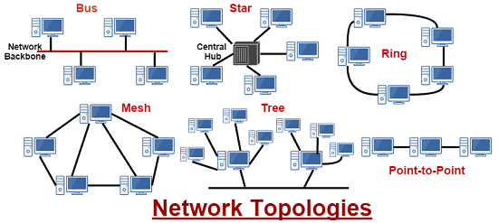

# Point-to-Point

## Point-to-point networks contains exactly two hosts such as computer, switches or routers, servers connected back to back using a single piece of cable.

## IMG_256

Often, the receiving end of one host is connected to sending end of the other and vice-versa.

# Bus Topology

## In case of Bus topology, all devices share single communication line or cable.It is one of the simple forms of networking where a failure of a device does not affect the other devices.

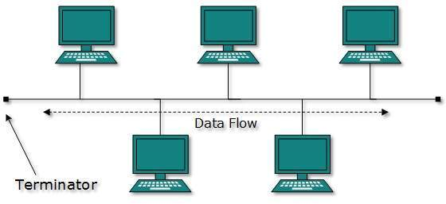

## But failure of the shared communication line can make all other devices stop functioning.

# Star Topology

## All hosts in Star topology are connected to a central device, known as hub device, using a point-to-point connection.

## That is, there exists a point to point connection between hosts and hub. The hub device can be any of the following:

## Layer-1 device such as hub or repeater

## Layer-2 device such as switch or bridge

## Layer-3 device such as router or gateway

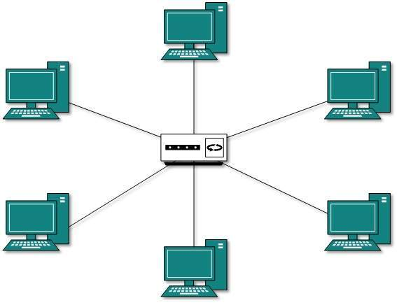

## As in Bus topology, hub acts as single point of failure. If hub fails, connectivity of all hosts to all other hosts fails.

# Ring Topology

## In ring topology, each host machine connects to exactly two other machines, creating a circular network structure.

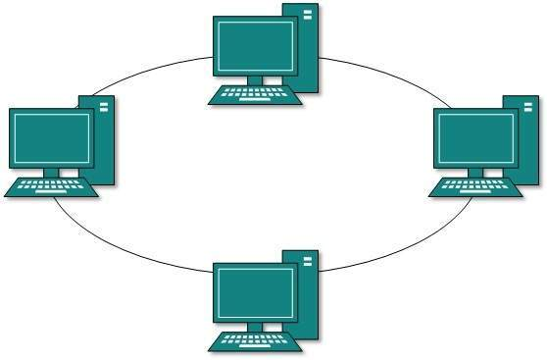

## When one host tries to communicate or send message to a host which is not adjacent to it, the data travels through all intermediate hosts.

## Failure of any host results in failure of the whole ring.Thus, every connection in the ring is a point of failure.

# Mesh Topology

## In this type of topology, a host is connected to one or multiple hosts.This topology has hosts in point-to-point connection with every other host or may also have hosts which are in point-to-point connection to few hosts only.

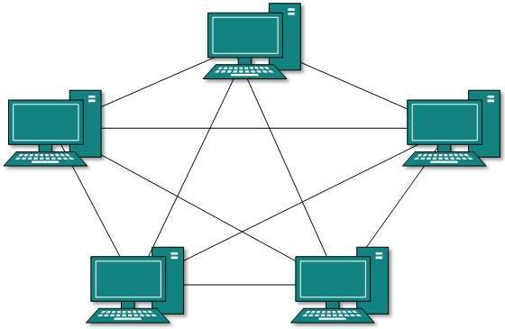

# Tree Topology

## Also known as Hierarchical Topology, this is the most common form of network topology in use presently.This topology imitates as extended Star topology and inherits properties of bus topology.

## This topology divides the network into multiple levels/layers of network.

## IMG_261

## All neighboring hosts have point-to-point connection between them.Similar to the Bus topology, if the root goes down, then the entire network suffers even though it is not the single point of failure.